=============== **Dealing with input during runtime** ==============

1. Write a JAVA program to find maximum of three numbers taken as user input by following methods:
   1. Using command-line arguments
   2. Using Scanner() class
   3. Using DataInputStream() class **3+3+4 = 10**
2. Write a JAVA program using recursive method to
   1. Calculate factorial of an integer
   2. Print n-th (n ≥ 0) Fibonacci number
   3. Test whether a number is a Fibonacci number or not
   4. Test whether a number is prime or not
   5. Calculate the GCD of two numbers taken as user input
   6. Implement a tower of Hanoi
   7. Print permutation of n input (e.g., ‘A’, ‘B’ or ‘1’, ‘2’). Value of ‘n’ is taken as user input.
   8. Print combination of n input (treat as string) taken from user. (E.g., ‘A’, ‘B’ or ‘1’, ‘2’). Value of ‘n’ and ‘r’ are taken as user input. **2+3+3+2+3+3+4+5 = 25**

=============== **Dealing with Coordinate Geometry** ==============

1. Write a JAVA program to do the following:
   1. Declare a class **Point** representing a point in 2D coordinate space **-100 ≤ x, y ≤ 100**.
   2. Define a constructor to initialize a point object chosen in uniform random within the specified range.
   3. Define another class **Circle** using the point as its center and another point as the circumference.
   4. Define a constructor that would randomly decide any point as the point on a circle object.

[PTO]

* 1. Write a main class **CoGeo** that will read an integer (say n) as the number of circles to be instantiated.
  2. Create n circles.
  3. Find any circle(s) that is inside any other circle or not. **2+2+2+1+2+2+4 = 15**

=============== **Dealing with Package** ==============

1. Take the program #3 and do the following:
   1. Create three directories: point, circle, test
   2. Put the class **Point** in ‘point’ directory and declare that it is under package point.
   3. Put the class **Circle** in ‘circle’ directory and declare that it is under package circle.
   4. Put the class **CoGeo** in ‘test’ directory and declare that it is under package test.
   5. Run the program from ‘test’ directory. **1+2+2+2+3 = 10**

=============== **Dealing with Inheritance** ==============

1. Write a JAVA program to do the following:
   1. Create three objects each of the following classes: person, student, employee
   2. Create an array of 10 persons
   3. Read data() using readData() for each objects and store it in the array ‘person’
   4. Print the data() of each object **20**

(See the picture in the next page)

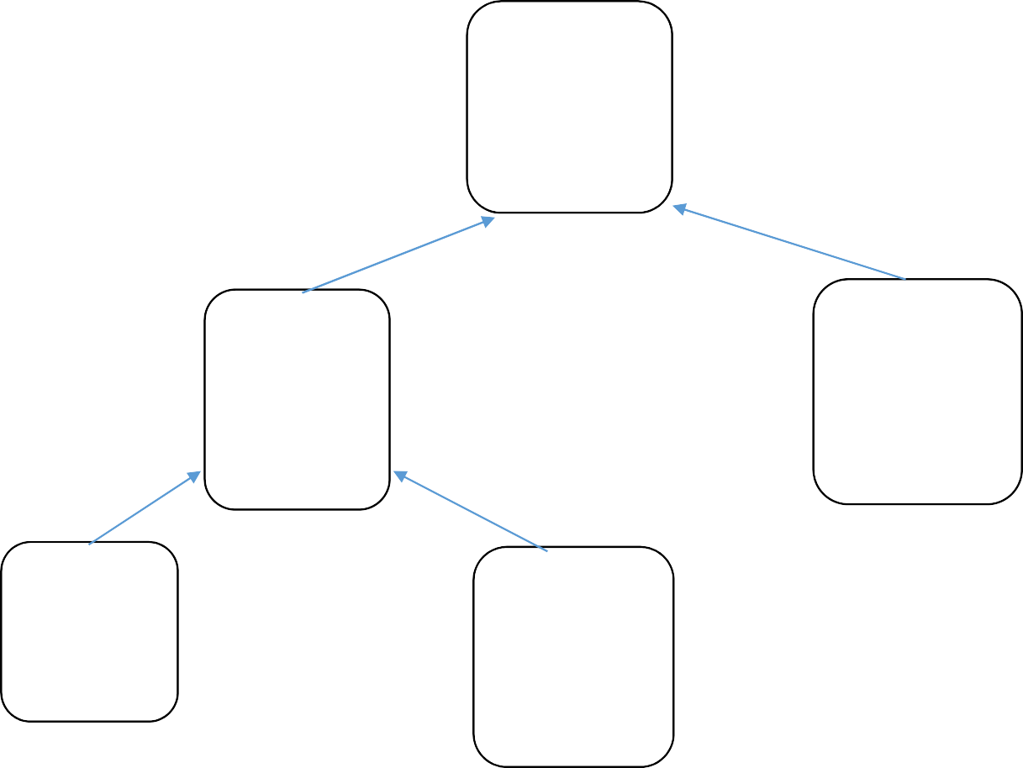

**Person**

* ID
* Mobile No
* ReadData()
* PrintData()

**Student**

**Employee**

•

•

•

•

•

•

Category

Roll No Department Marks[] ReadData() PrintData()

* EmployeeCode
* Salary
* Designation
* DateOfJoining
* ReadData()
* PrintData()

**PG**

**PhD**

* Project
* Supervisor
* ReadData()
* PrintData()
* Thesis
* Department
* Area
* Publication[]
* ReadData()
* PrintData()

********************************* THE END *********************************